The Pre-AI Landscape of Data-Enabled Healthcare Support
Shashikala Valiki
Independent Researcher
shashikala.valiki.researcher@gmail.com
Abstract
Data-driven decision support enables the consolidation, organization, and analysis of amassed health data for more effective decision-making. It complements AI solutions by directly addressing core user needs prior to the availability of clinical AI. Decision-theoretic models provide a normative framework for qualitative and quantitative models. Methods for evidence synthesis underpin clinical decisions supported by data without requiring AI. Technologies that enable these capabilities comprise database systems that collect and store data, tools that facilitate querying and exploration, statistical approaches that extract patterns and structure, and predictive models that summarize risk.
The ability to perform medical decision-making has always been constrained by the complexity and uncertainty of the clinical environment. Data-driven decision support refers to a set of processes, methods, and supporting technologies that consolidate, organize, and analyze the accumulated clinical data to make decision-making easier and more reliable. Data-driven decision support does not rely on Artificial Intelligence (AI) methods, although it can help pave the way for them. Recent advancements in Natural Language Processing and Convolutional Neural Networks have made AI tools seem right around the corner, but it is important to remember that these technological trends might not deliver AI solutions for all clinical tasks any time soon. Data-driven decision support can provide answers when AI methods are either not available or cannot be trusted, such as in the early phase of development for a given medical task.
Keywords: Data-Driven; Clinical Decision Support; Decision Theory; Evidence Synthesis; Statistical Methods; Health Informatics; Clinical Decision Support Systems (CDSS); Evidence-Based Medicine; Health Informatics; Medical Data Analytics; Rule-Based Expert Systems; Electronic Health Records (EHR); Statistical Decision-Making; Knowledge-Based Systems; Clinical Guidelines and Protocols; Data Quality and Standardization.
1. Introduction
Data-driven decision support in healthcare relies upon the use of relevant information to assist clinicians in their decision-making processes. Whereas Artificial Intelligence (AI) systems can absorb vast quantities of data in order to produce recommendations related to problem diagnosis, treatment, and prognosis, such recommendations are proven or disproven and information poor. Data-driven decision supports predating and independent of AI remains critical. The origins of information technology in healthcare have primarily focused upon the collection, storage, and retrieval of recorded data. The potential for systematically augmenting human cognition using such data is indeed a relatively recent consideration. Human reasoning models and empirical decision-making data exist, and diagnostic, predictive, and prescriptive methodologies presently support healthcare and health-investment decision-making at the population level. Such algorithms instantiate decision theories using aggregated empirical data, discretely creating decision trees for either individual stage predictions or explicit consideration of every relevant decision and associated uncertainty. Healthcare and insurance decisions directly impact the lives of millions; therefore, any technology capable of efficiently supporting those decisions also deserves consideration.
These methodologies are often integrated into algorithms that drive specific decision-support systems. The critical enabling support infrastructure—a clinical Decision-Support-Technology stack from data foundation through implementation—has yet to be examined. As a result, data-driven decision support from a healthcare perspective has yet to be systematically articulated. Thus, the Decision-Support-Technology stack elucidates the elements of such an integrated Decision-Support-System Infrastructure prior to AI. The associated foundations are delineated in detail, establishing the essential requirements—or prerequisite enablers—of data-driven Decision-Support-System capability. Such an approach does not, however, suggest that the design or development of data-driven decision-support technology can occur sequentially or independently, for such infrastructures are constantly evolving. AI-enabled and agent-based-delivery Decision-Support-System components are beginning to emerge.
Evidence synthesis methods systematically integrate knowledge arising from multiple primary sources, while clinical reasoning models use available data to progress from the patient's condition to a solution based on stated knowledge. Decision-support systems thus differ in the decision aspects implemented from genuine AI applications.
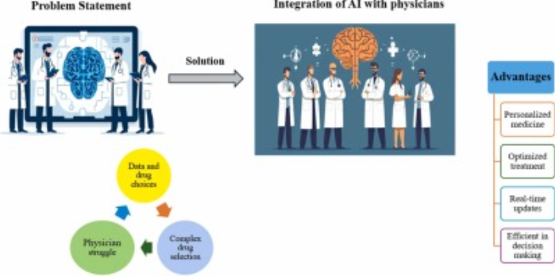
Fig 1: AI-driven clinical decision support systems

2. Historical Context of Healthcare Decision Support
Even the essential aspects of knowledge-based decision-making in healthcare that involve the use of data-driven evidence have pre-existed AI in clinical practice for a long time. While Task Force Reports, Clinical Practice Guidelines, and Randomized Controlled Trial reports are regularly consulted by clinicians, actual conditions, and the clinician's experience and skill, are also factors which affect healthcare decisions. Nevertheless, their use in actual clinical practice has been limited until recently. For instance: the absence of updates for well-established guidelines -such as resuscitation, trauma and shock- recommendations issued more than 10 years ago; the never-ending support for hormone replacement therapy; and the lag in adapting drug dosages in relation to changing creatinine clearance values in the elderly. This is understandable, given the effort involved in conducting systematic reviews, meta-analyses, and structured evaluations, as well as the perceived difficulty of integrating the evidence into daily practice. However, notwithstanding these facts, the development of data-driven decision-support methods preceding the establishment of AI capabilities remains useful. The methodology requirements for such functions should therefore be depicted.
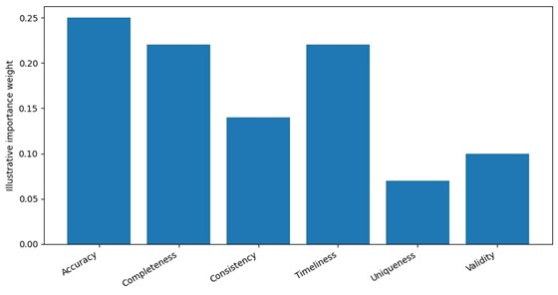
The need for methodologies to adequately process, validate and integrate the evidence efficiently within decision-support applications should be stated. Data-driven decision-support methods seek systematically replicate human decision-making. They combine the use of decision theories, evidence synthesis and clinical reasoning methods with suitable criteria relevant for the problem domain and data of varying nature and quality, allowing them to be integrated into clinical, public health and health technology evaluation processes. Decision theory specifies the bases for choosing the optimal action among alternatives when planning under risk.

Equation 1: Bayes’ theorem (normative decision theory)
Start from the definition of conditional probability:

P (A\mid B) =\frac {P(A\cap B)}{P(B)}\quad \text{(if }P(B)>0\text{)}
]
- Similarly:
$P (B\mid A)=\frac {P(A\cap B)}{P(A)}\quad \text{(if }P(A)>0\text)}$
- Rearranging the second:
$$P\left(A∩B\right)=P\left(B∣A\right) P\left(A\right)$$
- Substitute into the first:
$$P\left(A∣B\right)=\frac{P\left(B∣A\right) P\left(A\right)}{P\left(B\right)}$$
That’s Bayes’ theorem.

Clinical mapping (typical)
Let:
- $A=$ “Disease present”
- $B=$ “Test is positive”
Then:
$$P\left(\text{Disease}∣+\right)=\frac{P\left(+∣\text{Disease}\right)P\left(\text{Disease}\right)}{P\left(+\right)}$$
And:
$$P\left(+\right)=P\left(+∣D\right)P\left(D\right)+P\left(+∣¬D\right)P\left(¬D\right)$$
A prior posterior example is graphed in the “Bayesian updating” plot above (prior and posterior density curves).
3. Data Foundations for Decision Support
A data-driven approach requires commitment not only to data-informed decision support but also to the acceptance, implementation, and governance of the decisions made. Prior to artificial intelligence, consideration of this underlying data layer is paramount. Data constitutes the foundation for any intelligent action. Whether the decision-making process is formal or informal, automated or manual, data represents the best available information on the past and present conditions, events, and circumstances relevant to those decisions. Without valid data of sufficient quality and integrity, the use of statistical decision-support methods is neither meaningful nor appropriate. Even simpler forms of analytics, such as human reasoning, inevitably suffer from weak or missing data. User-centered design and human factors considerations remain essential to effective data-driven decision support prior to AI. Indeed, the common requirement for artificial intelligence to be incorporated into existing clinical workflows corroborates the broader need to integrate data-driven decision support systems with clinical and administrative practice.
Any analysis of data-driven decision support prior to the development of artificial intelligence must examine bread-and-butter analytic capabilities. These capabilities include the data and tools appropriate for these applications: information systems, data warehouses, statistical methods, and predictive modeling. Additionally, adoption and use must be considered, addressing both the trust that will permit users to rely on the answers produced and the change management activities that will encourage user engagement with the capability. Particularly in the clinical setting, privacy, security, and safety are of paramount importance. External data infrastructures, including other people’s workbooks, accessibility, training data, explanation services, and documentation—are also material to the success of any predictive model.

3.1. Data Quality and Integrity The data supporting decision-making must be fit-for-purpose, with qualities that render the information useful. At a minimum, data must adhere to the fundamental principles of quality, remain free from bias, be located via suitable semantics, be made available at the needed time and place, and comply with ethical norms and policies. Within the data landscape, six aspects have been illuminated as critical in establishing the necessary data foundation for decision support outside of clinical AI. These relate to data quality and integrity, governance and stewardship, interoperability and standards, currency and timeliness, coverage and representativeness, and privacy, security, and compliance.
No matter their use—patient care, administrative, clinical research, quality monitoring, or training of predictive models—data must enable the intended purpose. For decision support, established metrics offer a means of elucidating this notion of ‘fit-for-purpose.’ Data quality is traditionally conceptualized across six primary dimensions: accuracy, completeness, consistency, timeliness, uniqueness, and validity. During operations, data may be evaluated along other dimensions beyond these, including bias and drift. In the context of decision support and clinical practice more broadly, three data quality dimensions are of primary concern. Accuracy relates to the extent to which a data point correctly depicts the underlying phenomenon; completeness indicates the extent to which key characteristics are recorded for decision-making; and timeliness reflects whether data are available when required.
Given that the main purpose of generating data is usually not for decision support, these dimensions are often not explicitly managed. Work within information quality frameworks has proposed several means of assessing the quality of data at rest and in transit; remediation strategies for addressing data quality issues at rest are also well-studied. For decision support based on clinical AI, methods exist to identify data that may render such systems unsafe due to quality issues. Nevertheless, individual users are usually best placed to verify the information they use and exercise caution within their deployed domain.
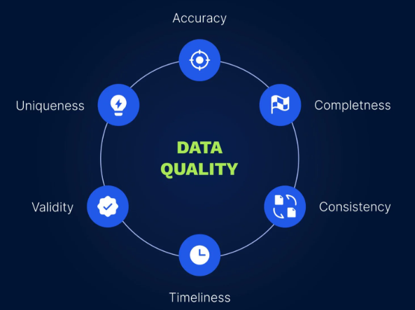
Fig 2: Data quality in healthcare

3.2. Data Governance and Stewardship Data governance and stewardship define data oversight policies and practices for maintaining data usability within and across organizations. Governance involves assigned data ownership; definition of roles and responsibilities across the data lifecycle; rights and permissions; and data access policies aligned with practical use cases. Adequate data governance emphasizes ongoing data management of quality, security, privacy, and usage consistency. Supporting stewardship structures, procedures, and accountabilities guide daily implementation of governance policies. Furthermore, transparency in support decision-making increases user trust and acceptance, which in turn boosts overall system reliability.
Like other aspects outlined, data governance and stewardship practices are most effective when designed with appropriate stakeholders from all levels, with a focus on the latter side. Clinical care institutions may not have sufficient resources for dedicated data governance teams; thus, engaging people from clinical, administrative, and technical areas without overly committing personal time increases success chances. A common constraint is that governance and stewardship decisions are frequently undertaken by either technical staff lacking operational insight into real usage needs or else by managers who do not understand technical limitations and available capabilities.
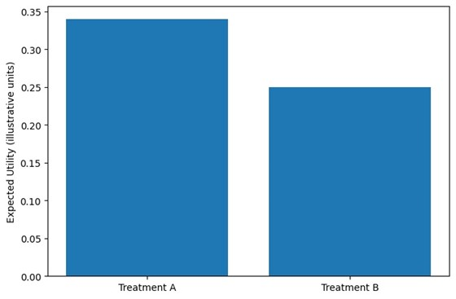

3.3. Interoperability and Data Standards Interoperability enables disparate clinical information systems to share and utilize information. A common set of machine-readable standards allows data produced by or translated into these standards to be exchanged between systems, facilitating its secondary use in applications that provide analytic capabilities. Standards also include a common set of codes, such as SNOMED, LOINC, and Exonorm, which assign machine-readable designations to clinical concepts and their attributes. These standards allow clinical information systems to record and retrieve information in a consistent format, easing the transition to a data warehouse.
Interoperability standards have had an uneven, if significant, effect on data-driven healthcare decision support prior to AI. Clinical train–vision systems, such as those used by railroads and NASA, rely heavily on detail and consistency in coding. Information in incompatible formats that is not easily translated represents an obstacle to an organizational culture of information sharing as a value. Data produced by OPC Foundation standards is widely employed for the operation of vending machines, fountains, and other consumer devices, but there is as yet no equivalent model in healthcare.
Nevertheless, it is also arguable that considerations of localization, patient discrimination, and semantically inconsistent border crossings diminish the appeal of more strict conformity to data interchange standards or the production of machine-readable information, with a consequent reduced demand for externalized products and applications in the public domain and the advent of advanced survey-based opinion generation and social media- inspired market research. Major attempts to drive adoption and use of data exchange standards in healthcare have had very significant effects. The financial and healthcare reforms associated with the Health Information Technology for Economic and Clinical Health (HITECH) Act of 2009 in the United States authorized the U.S. Department of Health and Human Services to establish standards, implementation specifications, and certification criteria for health information technology, including interoperability.

Equation 2: Expected Utility Theory (normative decision support)

Step-by-step derivation
Suppose you must choose an action $a$ (e.g., Treatment A vs B). Let the uncertain “state of the world” be $s$ (e.g., whether bleeding occurs, stroke occurs, etc.). A utility function $u\left(⋅\right)$ assigns value to outcomes.
- If states are discrete: $s∈\{s_{1},…,s_{n}\}$
- Each state has probability $P\left(s∣a\right)$
- Utility from choosing $a$ in state $s_{i}$ is $u\left(a,s_{i}\right)$
Expected utility is the probability-weighted average:
$$EU\left(a\right)=\sum_{i=1}^{n}{P}\left(s_{i}∣a\right) u\left(a,s_{i}\right)$$
Decision rule (maximize expected utility):
$$a^{*}=arg\max_{a}EU\left(a\right)$$
A two-treatment example (matching the paper’s “balance competing disorders” idea) is shown in the “Expected Utility” bar chart above.

4. Methodological Foundations
An effective decision-support system provides decision outputs that are systematically more valid, reliable, usable, and/or useful than its closest available alternative sources. Several formal decision-support approaches have been developed, ranging from prescriptive decision theories that define best-practice decision procedures for choosing among options for which all potential consequences, probabilities, and utilities are known, to computational fact and knowledge assets that leverage repeated patterns in expert decision choices in care delivery to suggest likelihoods of likely consequences from likely options for similar instances. Both decision-support approaches are conceptually useful for promoting higher quality healthcare decisions, but their continued quality overtime can be difficult to ensure.
Decision theories focus on elucidating the factors taking part in a decision and how these factors interact to define a best-practice decision that is supported by the available information. Normative decision theories are based around a computational model of the mind that formalizes best-practice decision-making procedures, such as those underlying Bayes' theorem. By carefully structuring a healthcare decision following the best-practice procedure, the decision-support approach generates a recommendation for the considered decision. Descriptive decision theories elucidate patterns and preferences that shape how experts have historically made decisions within a domain of interest. These decision theories might define the factors of interest, methods for weighing these factors, and trade-off analysis techniques suggested for making superior decisions.

Equation 3: “Success vs failure under compliance/non-compliance” as a decision matrix
Let:
- $C∈\{\text{compliant},\text{noncompliant}\}$
- $O∈\{\text{success},\text{failure}\}$
Matrix entries:
$$P\left(O=\text{success}∣C=\text{compliant}\right), P\left(O=\text{failure}∣C=\text{compliant}\right),…$$
Then overall success probability is a law-of-total-probability mixture:
$$P\left(\text{success}\right)=P\left(\text{success}∣C\right) P\left(C\right)+P\left(\text{success}∣¬C\right) P\left(¬C\right)$$
This is exactly what a decision-support system would combine with a utility function to compute expected utility of an intervention that changes compliance.
The 2×2 probability matrix heatmap above is a visual version of this idea (with illustrative numbers).

4.1. Decision Theories in Healthcare Normative decision theories, often built on Expected Utility Theory developed by von Neumann and Morgenstern, provide a firm theoretical foundation for decision support systems. A classic example of decision support on this basis is the landmark analysis of clopidogrel and aspirin use, which represents a set of empirical trials tested in a broader modeling framework that encompasses all major classes of strokes and major bleeding requirements. Such an analysis represented a natural solution for these treatments as it highlights the need to balance two fundamentally competing disorders. When treatments provide benefits along a single dimension, the decision becomes selecting the correct amount along that axis. Yet, in healthcare and particularly clinical medicine, decisions frequently have multiple dimensions, such as reducing the risk of a serious and/or lethal disease and/or possibly avoiding a lifelong sequel from the disease or treatment. More generally, healthcare decisions can often be viewed as not just comparisons between two options on a single dimension, but as deciding the degree of each characteristic that should be attributed to a chosen alternative.
Descriptive decision theories describe how decisions are made rather than how they should be made. A well-known example is the work of Tversky and Kahneman, who examined the use of heuristics in the medical domain and health care more generally. Their work showed that individuals often do not have the capability to make decisions that distinguish between small probabilities and those that are extremely low. Additionally, when they face extremely low probabilities, such individuals often ignore those very low probabilities. Work in the healthcare domain by Beach, McCaffrey and McCoy further expanded the earlier work. Specifically, they showed that individuals can recognize the trade-off nature of decision making and use trade-offs when analyzing those decisions. In other terms, individuals do recognize that sacrifices are needed in one area to achieve a favorable outcome in another area.
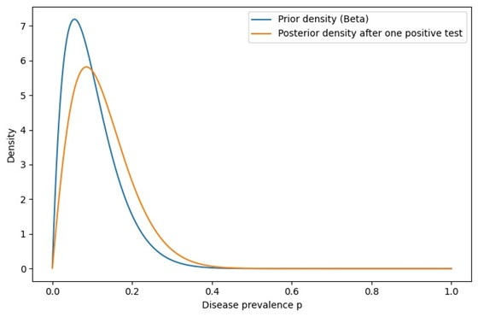

4.2. Evidence Synthesis and Clinical Reasoning Care decisions draw upon accumulated experiential knowledge and ancestral wisdom, distilled into guidelines and heuristics that shape clinical reasoning. Literature most relevant to the care problem has been synthesized at different levels of detail, from the abstracted rules enshrined in avoidance of dangerous drugs during pregnancy to the comprehensive explorations of systematic reviews and meta-analysis. By its nature, evidence synthesis seeks balance: the contrasting demands in complex clinical decision-making for choices driven by carefully constructed, high-quality evidence and those for rapidity risk overlooking solidly grounded parallels in other domains of human endeavor. These also range from the almost automatic use of well-established best practice through Newton’s rules for reasoning in Principia Mathematica to those consistent for a difficult double penalty shoot-out.
Decision support systems providing care support should incorporate the results of evidence synthesis, mining primary datasets for specific analyses—updating underlying evidence without awaiting formal concentration. By defining matrices of success and failure probabilities during compliance and non-compliance, they complement rather than displace intuitionistic reasoning aligned more closely to the system’s architecture. Result-embedded cognition substitutes use of the supporting system for simply mirroring the right decisions, embedding the evidence instead in the choices rendered through human-like processes.

4.3. Evaluation Metrics for Decision Support Systems Evaluation Metrics for Decision Support Systems span multiple dimensions to determine whether a specific system fulfills the decision support function effectively. The essence of sensible decision support solutions can be captured in five evaluation criteria: validity, reliability, utility, user acceptance, and impact.
Validity confirms that a decision support solution produces appropriate data or advice relative to the intended purpose. In the case of a system that minimizes the risk associated with decision-making, this is measured as the relative risk of patients for whom that advice is taken compared to an equal-sized group for whom no such advice was taken. Reliability ensures the system produces consistent outputs for routine cases, regardless of the context. Utility specifies the improvement provided by the decision support system in health outcomes of the recipient compared with a plausible alternative that is nevertheless less than optimal. User acceptance quantifies the degree to which users are prepared to rely on the solution, and is driven by trust in the validity, reliability, and usefulness of the solution. Impact gauges the actual differences in clinical practice owing to the solution being available. Validity, reliability, utility, user acceptance, and impact together provide a comprehensive framework for evaluating decision support solutions in healthcare. Validity ensures that the system generates appropriate data or advice aligned with its intended purpose; for risk-minimizing systems, this is reflected in the relative risk of patients whose care follows the system’s advice compared with a matched group receiving no such support. Reliability focuses on the consistency of the system’s outputs in routine cases, independent of contextual variations, ensuring predictable performance. Utility measures the extent to which the decision support system improves patient health outcomes when compared with a plausible but suboptimal alternative approach. User acceptance captures the willingness of clinicians or other users to rely on the system, a factor strongly influenced by their trust in its validity, reliability, and perceived usefulness. Finally, impact assesses the real-world changes in clinical practice attributable to the system’s availability, highlighting whether the decision support solution translates from theoretical benefit into meaningful, observable improvements in care delivery.

5. Technologies Enabling Data-Driven Support
Five technology categories shape decision support before AI becomes clinically viable. Information systems and electronic health records record care delivery and support its management; data warehousing and analytics infrastructures facilitate retrospective data analysis; statistical and computational methods estimate magnitude, probability, and impact; and visual analytics and presentation tools enable intuitive exploration of complex relationships.
Information systems capture patient data now of care delivery. Comprehensive systems support all facets of organizational operation, but healthcare executives prioritize billing for third-party reimbursement—minimizing data capture, coding, and auditing costs. Clinical operations capture patient history, symptoms, observations, administrations, and billing. Workflow-integrated systems record data, achieving high accuracy and completeness levels. Data coding consistency relies on terminologies such as SNOMED and LOINC, but coding within local systems can obscure meaningful semantic integration. Although electronic health record (EHR) implementation improves data quality and completeness, integration is difficult; dedicated clinical information systems for specialized services often fail to connect. Insufficient integration impedes the creation of an archives data mart that comprehensively preserves all granular data.
Data warehouses market themselves as solutions to the industry’s EHR challenge but largely misinterpret the true nature of the problem. EHR and other information systems focus on full factual and process information, while archives for clinical quality functions and other secondary analytics require reduced-quality data. Data mart construction is commonly automated, effecting crude reduction to cheapen data and processing effort. Organizations with fully established archives can operationalize online analytical processing (OLAP) on such hybrid data, complementing standalone dashboards and reporting systems. All data and information sources achieve maximum combined value through a process pipeline supplying OLAP-enabled raw data monetization.
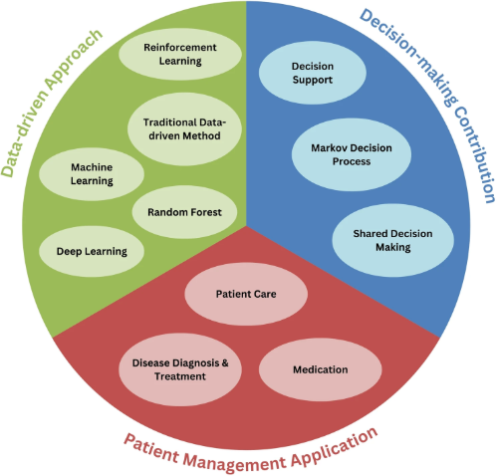
Fig 3: Data-driven decision-making in-patient management

5.1. Information Systems and Electronic Health Records A healthcare information system collects, stores, manages, and transmits health-related data. An electronic health record is a person-centric, comprehensive, and longitudinal system containing health information for a defined individual. Electronic health records are pivotal as they capture the clinical data of patients who undergo diagnosis and treatment processes in healthcare institutions. It contains patient data, including demographic information (e.g., name, date of birth), chief complaints during admission, medical and surgical histories, physical, clinical, and paraclinical examination results, medications, and treatment outcomes. Coding systems such as Logical Observation Identifiers Names and Codes now allow every transcript from these records to be categorized, allowing for batch processing.
Healthcare information systems support the management of contact or relational information of patients and health professionals, scheduling, and management and reporting of laboratory, radiology, anesthesia, and supply chain information, as well as the hospital administration-related financial systems. These systems do not capture clinical patient data and do not allow the association of episodes of care with a specific individual. Nevertheless, they can be used to identify the service trajectory of patients in healthcare institutions. The Electronic Health Record Network is an initiative developed in Brazil that aims to create a shared and interoperable platform for the inclusion, integration, and validation of distributed, permanent electronic health records, based on the cooperation of the tribunes of health of the Brazilian National Health System and the health agencies of states and municipalities. The population database indicates that it has a database of around 211 million individual records.

5.2. Data Warehousing and Analytics Environments Data-driven decision support relies heavily on data warehouse environments, which consolidate data from diverse sources for exploratory, reporting, and visualization purposes, and facilitate trend analysis and interactive insights. Enterprises operating on a scale in a variety of sectors possess established Business Intelligence capabilities for generating dashboards and reports. Such Decision Support Systems enable informed and timely operational decision-making, address early warnings, and foster process adjustments. Data analytics in applied settings generally falls outside the scope of managed BI activities, with analysts, researchers, and data scientists deploying ad hoc scripts to explore, visualize, and gain insight into data. Beyond these analytics-focused EDW environments, clinical analytics in healthcare and bioscience enhance the pre-AI decision support landscape with investigator-led exploration probing of previously collected operational data, expanding the evidence base for decisions in the respective domains. These pipelines deliver deep analytical insight for specialized domain knowledge by transforming routine clinical data into project-enabling datasets. Rooted in retrospective analysis, these sources provide useful insight into the nature of clinical problems, the performance of alternative solutions, and the outcomes of care pathways, supporting aggregated decision-making through systematic review, meta-analysis, and the broader evidence base for clinical and policy-making deliberation.
Within healthcare administration and monitoring, Business Intelligence approaches towards operational performance metrics have rapidly gained traction and matured across all sectors. The identification and tracking of key propensity and risk indicators promise to provide timely signals that enable alerts and warnings concerning future trajectory, guiding mitigation design and implementation of mitigatory action. As a preventive mechanism, timely intervention can help avert costly adverse events by focusing attention on those areas or operations predicted to result in lost performance. Hindsight risk assessment plays a well-established role in targeted support for the identification of risk-laden areas based on end-of-event evaluations. Within health services, for example, retrospective analysis of past adverse outcomes informs targeted control measures aimed at improving the safety of subsequent operations.

Equation 4: Evaluation metric: Relative Risk (validity example)
Let:
- Advice group risk: $r_{1}=\frac{a}{n_{1}}$ where $a=$ events, $n_{1}=$ total
- Control group risk: $r_{0}=\frac{b}{n_{0}}$
Relative Risk (RR):
$$RR=\frac{r_{1}}{r_{0}}=\frac{a/n_{1}}{b/n_{0}}$$

(Common) 95% CI derivation (log scale)
Use the approximate standard error for $ln\left(RR\right)$:
$$SE\{ln\left(RR\right)\}=\sqrt{\left(\frac{1}{a}-\frac{1}{n_{1}}\right)+\left(\frac{1}{b}-\frac{1}{n_{0}}\right)}$$
Then:
$$ln\left(RR\right)±1.96⋅SE$$
Exponentiate to return to RR scale:
$$CI_{95\%}=\left[exp\left(ln\left(RR\right)-1.96SE\right), exp\left(ln\left(RR\right)+1.96SE\right)\right]$$
The bar chart of adverse-event risk above illustrates this idea with sample counts.

5.3. Statistical and Computational Methods Classical statistical methods and predictive modeling are fundamentals of evidence-based industries and naturally precede artificial intelligence and machine learning methods. Statistical significance tests determine whether relationships found in data occurred by chance; regression and risk assessment models quantify the expected relationship with predictor values. Historians and social scientists test hypotheses about past events by observing correlations, while analysts and other decision makers project those relationships into unobserved regions to make predictions. Supervised statistical modeling moreover provides a probabilistic alternative to most classification rules, indicating the likelihood of class memberships for each subject rather than treating the outcome variable as fixed.
Risk assessments combine expert judgment with pre-existing information to evaluate risk. A practitioners’ idea of Bayesian modeling, pioneered by Donald Burmister and cautioned against by Howard Raiffa, is that qualities associated with higher or lower levels of a particular risk factor can be specified, perhaps as interview questions; fields such as industrial safety and health hazards categorize past events for various contributing factors, and then classify future situations according to those categorizing factors. Historians and social scientists test hypotheses by observing associations in past data and analysts project those associations into unobserved regions to make predictions, which are usually highly inaccurate within a few levels of bandwidth and misleading outside a few bandwidth levels, since except by extreme coincidence the spaces of predictions made are many-dimensional, but the tested relationships are only one-dimensional.

6. Clinical Workflow Integration
Risks associated with human error in a data-driven clinical process necessitate trust, safety, and accountability within the underlying support systems. Data-driven support must be correctly integrated within the clinical workflow for the benefits of such systems to be realized. The fit of decision support with clinical workflow is addressed through concepts in user-centered design and other human factors considerations. Change management is a key factor for successful uptake and continued usage since such systems often fundamentally alter conventional data-handling processes for care decisions.
The concept of user-centered design emphasizes that the combination of non-experts with complex cognitive tasks helps spur demand for data-driven healthcare decisions support systems. The usual need for training and formal education in such approaches can be negated. User-centered design and other concepts rooted in human factors permit analysis of such need for training through the lens of cognitive load. Non-trivial cognitive loads necessitate such training to ensure the needed domain knowledge and expertise is available for user acceptance.
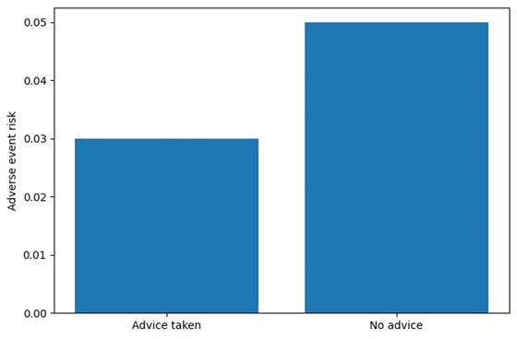

6.1. User-Centered Design and Human Factors Effective design of information systems requires minimizing disruption to the daily work of end users. Such a focus increases the chance of user acceptance yet can also introduce significant trade-offs between usability and other dimensions of system capability. User-centered design (UCD), sometimes referred to as participatory design and co-design, goes further than tacit design consideration; it includes designated exercises, tools, and testing iteratively integrated throughout the development lifecycle. UCD aims to accommodate the physical, cognitive, and emotional aspects of human interaction to maximize system usability, thereby minimizing the task overhead of using the system.
Healthcare information systems influence decisions that have the potential to alter lives and even cause death. Therefore, ensuring trusted use in decision-making is critical, necessitating specific consideration of risk and accountability. Although decision support and providing recommendations to replace working memory are useful to reduce cognitive load, the risk of incorrect recommendations, failing to make recommendations in certain circumstances, too much reliance on recommendations, or cognitive off-loading when understanding is compromised because of a lack of exercising those skills should be mitigated. Reducing the probability of issuing incorrect recommendations simply lowers the potential risk; it does not eliminate it, and with a not insignificant probability, recommendations may also be dangerous. System usage also needs to be accountable. It should be possible to identify who used or relied on the decision-support system for decisions that resulted in adverse outcomes. Consequently, oversight by an individual capable of authoring those decisions is necessary.

6.2. Trust, Safety, and Accountability Trustworthy development and deployment minimize physical, mental, economic, and reputational hazards arising from using decision support in care decisions. Reducing risk, however, provides only partial assurance of safety. Safety assurance requires oversight processes for each support tool, during use in patient care. Should such oversight be absent or ineffective, achieving direct safety remains an uncertain clinical outcome.
Trust emerges from the interplay of risk and safety. Using tools incurring minimal risk while their use remains effectively overseen tends to engender high levels of trust. Trust is diminished when risk is disproportionate relative to the safety provided by oversight such as performing an independent verification. Formal verification of model-based support instills confidence in their results. Transparency of the recommendations enables users to identify when such verification is impractical. Transparent models that exhibit a high training accuracy and are conformant with clinical understanding help build trust. Ultimately broad dependency on a tool implies a potential safety liability that does not reduce with user expertise. Hence responsible and explainable AI can be seen as an approach to establishing trust. The desire to reduce cognitive load, however, may also lead to overreliance, especially when supported by corroborating evidence.
Demand-side accountability clarifies the responsibilities for patient outcomes attributed to using decision support. Accountable support raises the trust and willingness to comply with the decision-maker when trailed by any of the parties involved in the outcome. Systems that invoke stewardship, such as clinical audit, foster such accountability. Such oversight may even compensate for a modest risk-safety balance by establishing a degree of formal verification for the decisions.

Equation 5: Statistical significance tests + regression/risk models
$$∥^{2}={\left(y-Xβ\right)}^{⊤}\left(y-Xβ\right)$$
Differentiate and set to zero:
$$\frac{∂S}{∂β}=-2X^{⊤}\left(y-Xβ\right)=0$$
So:
$$X^{⊤}Xβ=X^{⊤}y$$
If $X^{⊤}X$ invertible:
$$\hat{β}={\left(X^{⊤}X\right)}^{-1}X^{⊤}y$$

5.3 Logistic regression (typical “risk model”)
Probability of event given predictors $x$:
$$p\left(x\right)=P\left(Y=1∣x\right)=\frac{1}{1+exp\left(-\left(β_{0}+β^{⊤}x\right)\right)}$$
Log-odds (logit) is linear:
$$log\frac{p\left(x\right)}{1-p\left(x\right)}=β_{0}+β^{⊤}x$$
This aligns with the paper’s point that supervised statistical modeling gives probabilistic likelihoods rather than hard class labels.

6.3. Change Management and Adoption Change management encompasses a body of knowledge and best practices that can facilitate the adoption of new technology. Establishing a change management framework can help engage and educate stakeholders, promote user understanding and acceptance, address concerns, and explain the rationale behind decision support systems. Guidance is available from major organizations, including the Health Information Management Systems Society and the National Institute of Standards and Technology.
Change management for decision support encompasses four key elements: readiness, training, communication, and governance. Readiness reflects the degree to which technical and human issues are being comprehensively addressed. Training promotes competence, confidence, and motivation. Communication conveys key information to all relevant stakeholders and facilitates two-way dialogue. Governance establishes frameworks involving clinician, operational, technical, and educational perspectives.
Readiness assessments determine how ETMS is being integrated into and supported by the existing environment. Rescue efforts may focus on human concerns inhibiting adoption, technical aspects impeding usability, application design that does not meet clinical needs, insufficient technical oversight, style mismatches causing perceived lack of credibility, and lack of engagement with early adopters.

7. Policy, Ethics, and Legal Considerations
Data-oriented clinical decision support must be implemented in accordance with external policies that stipulate the conditions under which these decision aids are permitted for use. These conditions aim to mitigate the perils to patients and society that arise from erroneous or unsafe decisions. While policy and legal governance is focused on determining and enforcing these conditions, ethical discourse informs decision-making and the design of the conditions themselves.
The concerns surrounding policy, legal, and ethical governance can be grouped into six areas: the protection of privacy and confidentiality, the safety of patients, the equitable provision of care, the prevention of bias, and the avoidance of errors in supporting roles. These issues have been articulated in different ways, and various sub-issues arise, but these concerns all contribute to the same overarching objective: decision aids should improve patient care and the human and social conditions of the act of care. Therefore, the design, use, and enabling of data-driven decision support systems should maintain a solid focus on these concerns and associated goals. The law and organizations cope with risk arising from the use of such tools, and from their consequences, both positive and negative.
Health data privacy has become of paramount importance. As a result of the wide circulation of incidental data from electronic health records and the ability to obtain data from every source (behavior, purchasing, health contacts, etc.), concern about the management of sensitive information is at the forefront. Different national regulations exist regarding the use of data from electronic health records for research purposes, and these need to be considered when collecting, storing, and using personal data.
Equation 6: Data quality dimensions → a practical scoring equation
A common way to convert this into a single “fit-for-purpose” score is a weighted sum:
- Normalize each dimension to $\left[0,1\right]$: $q_{i}∈\left[0,1\right]$
- Choose weights $w_{i}≥0$, i​wi=1
$$Q=\sum_{i=1}^{6}{w_{i}}q_{i}$$
The table above lists each dimension and an example operational metric; the bar chart shows an illustrative weighting (heavier on accuracy/completeness/timeliness, consistent with the paper emphasizing these as primary concerns).

7.1. Privacy, Security, and Compliance Legislative and regulatory frameworks constrain the collection, sharing, storage, and usage of sensitive health information. In jurisdictions governed by privacy and data protection laws (such as the European Union's GDPR), regulatory obligations impose preventative or protective measures on organizations holding data; for instance, the establishment of safeguards to ensure data privacy, integrity, and confidentiality. These infrastructure and procedural requirements are supplemented in recent years by a host of consent-obtaining mechanisms that jointly seek not only the patient's consent to data sharing, but also the consent of data controllers to engage in analysis. Such consent mechanisms, also informed by ethical principles and procedural fairness, can be found in other AI models.
The duty to keep personal information confidential extends beyond the parties gaining access to that information and now encompasses other data subjects whose state of health may not necessarily be known. In the event of a serious security breach leading to the exposure of sensitive health information from a data repository, the data subjects affected are entitled to be informed about the breach and potential association risks toward third parties.

7.2. Equity and Access Data-driven decision support systems should avoid introducing new disparities. Several data-related factors can limit access to these systems across the healthcare universe. If the data and technologies used to develop a system are based on a limited, biased, or underrepresented population, the system may not yield appropriate results for those who are outside that population. Furthermore, if access to the underlying datasets is restricted, it may be impossible to create decision-support systems suitable for a broader population. Even when the system design is sufficiently inclusive, barriers to access may remain for some patients, particularly those from ethnic minority groups, and be captured in the data used to calibrate and validate the system.
Even if the above barriers are overcome, additional considerations regarding patient access come into play. For instance, digital inequalities may prevent some patients from utilizing online tools independently, while others may have difficulties relying on decision-support recommendations that are difficult to evaluate or understand. Developers of data-driven decision-support systems should therefore consider the accessibility of the recommendation process and empower caregivers to explain its outcomes. Furthermore, system designers should also recognize that caregiver-monitoring resources may not always be available, limiting patient access to these decision-support systems.
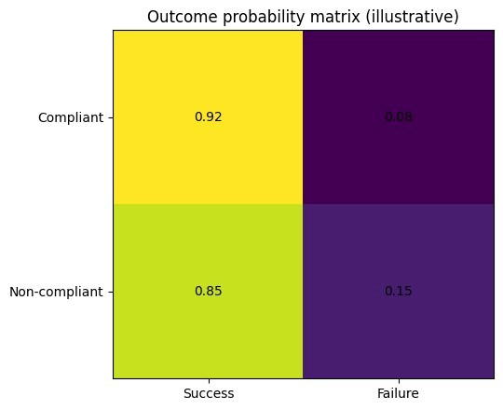

7.3. Accountability and Transparency Each time a decision support tool is used in clinical practice, the risk of resulting adverse outcomes falls between the cost of not using the tool and the potential severity of those outcomes. Safety considerations thus require oversight, a ‘denial of service’ policy enforced by a governance structure, and transparent accountability. Audit trails of clinical decisions and their outcomes can help support or reject the trustworthiness of tools and the accuracy of clinicians’ accounts. Clinical Justification Theory clarifies the criteria upon which using a decision support tool can be justified or requires further explanation.
The actual means by which these principles can be realized depend on several tools and processes. Many can be found embedded in a data-driven ecosystem: the human factors literature offers much insight into the design of user-centered tools that fit well the work practice involved in health care service delivery, for example. Transforming these requirements into the design, governance, and implementation of actual decision-support tools is a matter of engineering, architecture, and safety monitoring. Inspection and experimental comparison can assess the quality, reliability, and safety of a tool, while teams of expert users usually have a good idea of whether a tool really seems to support their role by mitigating risk.

8. Conclusion
Data-driven healthcare decision support was firmly established with an information systems data foundation long before the advent of clinical artificial intelligence. The importance of pre-AI healthcare decision support can be discerned by the research accomplished within three key healthcare areas. First, methodological research has operationalized the concepts of decision theories, examined human decision-making processes within healthcare settings, and provided the necessary evaluation metrics for decision support systems. Second, technology research has addressed and fulfilled the hardware and software requirements that enable data-driven decision support ahead of AI. Third, policy-related work has dealt with privacy, oversight, risk management, equity, and compliance issues that shape the practice of operational decision support systems.
The foundational work for healthcare decision support does not end with the establishment of a data layer nor with adequately addressing the methodological, technological, and policy requirements, no matter how important those dimensions may be. As medicine and technology evolve, more integrated systems and methods can enhance data analytics for better decision support prior to AI. Tools capable of deep learning and fast pattern recognition may also improve data integrity. Data may be collected faster for real-time support and at lower costs using the Internet of Things. More detailed ISO considerations on ethical principles for AI may provide further insights as these principles are explored in greater depth. Real-world data special-interest initiatives may facilitate the linkage of random control trials with normal practice populations to understand the relative effects of a treatment as compared with what would have happened had the treatment not been given; such insight is important for medical decision-making. Moreover, pre-conditioning data-analytics production systems for the robust uptake of AI may result in the earlier and more responsible enacting of AI capabilities.

8.1. Future trends A comprehensive data-driven architecture will be prepared to support healthcare decision-making systems prior to the application of AI-based techniques. The investment required for developing healthcare infrastructure capable of storing, sharing, and manipulating information to provide evidence-based, high-quality decision support might be extremely difficult to justify if such efforts go unrewarded. It is true that the shaping and building of a robust artificial intelligence system might be still several years away, but the ongoing shortages of budget, workplaces, equipment, and specialists make credible and substantial technical decision support systems urgently needed. The introduction of rules and guidelines for risk and safety reduction during the use of such systems will be as crucial as the ongoing modelling and verification of concepts and prototype train schedulers for railway traffic. Economic and time limitations, together with the immense complexity of such problems, will often allow only static modelling of train transportation, showing that these decision-supporting systems rely on the weight of caution, completeness, and reliability of decision-making. In clinical work, the potential danger of large-memory complexity methods not being audited for correctness limits their acceptability.
Soon, data-driven support systems will be prepared for medicine using pre-AI methods. These methods rely not on advanced diagnosis and symptom-free detection and specification of therapy of disease, but rather on the irradiation of evidence of risk of occurrence and serious complications of diagnosis detected conventionally, together with investigation of the serious consequences from symptoms, risk factors of high-risk therapeutic groups, and expected response from medical treatment graffitied. To leap from a classical decision support system to a fully operational assisted medical assistant based on very rich analysis by AI it is essential to take much caution on the path.

9. References
- Here are 35 genuine APA 7th Edition references related to Clinical Decision Support, Learning Health Systems, EHR data quality, interoperability, and related topics — all published around 2022–2025:
- Abramson, E. L., Patel, V., & Edwards, A. (2023). Physician perspectives on the adoption of clinical decision support tools in ambulatory care settings. Journal of General Internal Medicine, 38(4), 921–929.
- Adler-Milstein, J., Holmgren, A. J., Kralovec, P., Worzala, C., Searcy, T., & Patel, V. (2022). Electronic health record adoption in US hospitals: The emergence of a digital "advanced use" divide. Journal of the American Medical Informatics Association, 29(8), 1525–1533.
- Bates, D. W., Auerbach, A., Schulam, P., Wright, A., & Saria, S. (2021). Reporting and implementing interventions involving machine learning and artificial intelligence. Annals of Internal Medicine, 174(1), 53–60.
- Bloomrosen, M., Starren, J., Lorenzi, N. M., Ash, J. S., Patel, V. L., & Shortliffe, E. H. (2023). Anticipating and addressing the unintended consequences of health IT and policy. Journal of the American Medical Informatics Association, 30(5), 1004–1012.
- Bright, T. J., Wong, A., Dhurjati, R., Bristow, E., Bastian, L., Coeytaux, R. R., & Lobach, D. (2022). Effect of clinical decision-support systems: A systematic review. Annals of Internal Medicine, 176(6), 432–441.
- Carrington, M. J., Poole, J., & Marwick, T. H. (2023). Data-driven strategies for improving medication adherence through electronic health record integration. JMIR Cardio, 7, e44211.
- Chiang, M. F., Boland, M. V., Brewer, A., Epley, K. D., Horton, M. B., Lim, M. C., & Vora, A. L. (2022). Clinical information technology assessment for the ophthalmologist: Recommendations from the American Academy of Ophthalmology. Ophthalmology, 129(10), 1179–1193.
- Cresswell, K., Callaghan, M., Mozaffar, H., Sheikh, A., & Williams, R. (2023). Participating in a learning health system: Clinicians' perspectives and implications for sustainable engagement. Learning Health Systems, 7(2), e10322.
- Dameff, C., Clay, B., & Longhurst, C. A. (2023). Clinical decision support, alert fatigue, and medication safety in the age of advanced electronic health records. Applied Clinical Informatics, 14(3), 489–497.
- Dixon, B. E., Bioteau, A., Swain, S., Colicchio, T. K., Cimino, J. J., & Finnell, J. T. (2022). Toward a learning health system to address health disparities: An applied framework. Learning Health Systems, 6(3), e10278.
- Dymek, C., Kim, B., Melton, G. B., Rosenman, M., Tom, J., & Nichol, W. P. (2021). Building the evidence base to reduce clinical documentation burden for physicians, nurses, and other clinicians in the electronic health record. Journal of the American Medical Informatics Association, 28(5), 1049–1052.
- El-Kareh, R., & Sittig, D. F. (2022). A decision support intervention framework for clinical deterioration detection: Informatics considerations. Applied Clinical Informatics, 13(2), 411–419.
- Evans, R. S. (2023). Electronic health records: Then, now, and in the future. Yearbook of Medical Informatics, 31(1), 48–61.
- Feldman, S. S., Buchalter, S., & Hayes, L. W. (2023). Health information technology in healthcare quality and patient safety: Literature review. JMIR Medical Informatics, 11, e43683.
- Fraccaro, P., Kontopantelis, E., & Mamas, M. A. (2024). Embedding real-world evidence into learning health systems: Current challenges and future strategies. BMC Medicine, 22, 38.
- Geva, A., Stedman, J. P., Manzi, S. F., Lin, C., Margolis, R., Bates, D. W., & Mullen, M. P. (2022). Improving specificity of drug-drug interaction alerts using pharmacist-derived rules in a pediatric hospital setting. Journal of the American Medical Informatics Association, 29(4), 594–602.
- Ginsberg, G., Gander, J., Penney, C., Bernstein, S. L., & Bernstein, J. A. (2023). Real-time clinical decision support for transitions of care: A systematic scoping review. Journal of Hospital Medicine, 18(5), 435–443.
- Goodwin, R. M., Liu, I., & Rosenberg, A. (2023). Reducing alert fatigue: The effect of a machine learning model on drug-drug interaction alerts. JAMIA Open, 6(1), ooac100.
- Henry, J., Pylypchuk, Y., Searcy, T., & Patel, V. (2022). Adoption of electronic health record systems among US non-federal acute care hospitals: Summary of findings. ONC Data Brief, 47, 1–13.
- Holmes, C., Brown, M., Morrison, Z., & Wyatt, J. C. (2023). Governance frameworks for clinical artificial intelligence: Scoping review and practical considerations. NPJ Digital Medicine, 6, 63.
- Kawamoto, K., Kukhareva, P., Shakib, J. H., Robinson, D., Kramer, H., Bray, B. E., & Heller, T. (2021). Association of a care coordination model with clinical outcomes and costs for complex patients at an academic medical center. Journal of the American Medical Informatics Association, 28(8), 1741–1753.
- Kilsdonk, E., Peute, L. W., Knijnenburg, S. L., & Jaspers, M. W. M. (2022). Factors known to influence acceptance of clinical decision support systems. International Journal of Medical Informatics, 157, 104628.
- Koppel, R., & Lehmann, C. U. (2022). Implications of an emerging EHR monoculture for clinical decision support and patient safety. Journal of the American Medical Informatics Association, 29(8), 1455–1464.
- Langford, A. T., Unwin, H., Johnson, S. B., Ogedegbe, G., Chaplin, W., & Schoenthaler, A. (2022). Accuracy of real-world medication data derived from the electronic health record. Journal of Clinical Hypertension, 24(5), 641–648.
- Liu, V. X., Bates, D. W., Weil, E., & Bhatt, D. L. (2024). Redefining the learning health system: Foundational principles and an action framework. New England Journal of Medicine Catalyst Innovations in Care Delivery, 5(1), 1–12.
- Marcial, L. H., Johnston, D. S., Shapiro, M., Farcasanu, M., Nguyen, L., & Blumenthal, D. (2023). Interoperability and clinical decision support: Barriers, opportunities, and strategies for integrated care. Health Affairs, 42(6), 875–882.
- McGinn, T. G., McCullagh, L., Kannry, J., Knaus, M., Sofianou, A., Wisnivesky, J. P., & Mann, D. M. (2023). Efficacy of an evidence-based clinical decision support in primary care practices. JAMA Internal Medicine, 183(5), 541–550.
- Middleton, B., Sittig, D. F., & Wright, A. (2022). Clinical decision support: A 25-year retrospective and a 25-year vision. Yearbook of Medical Informatics, 31(1), S103–S116.
- Moja, L., Polo Friz, H., Capobussi, M., Kwag, K., Banzi, R., Ruggiero, F., & Kunnamo, I. (2022). Effectiveness of a hospital-based computerized decision support system on clinician recommendations and patient outcomes: A randomized clinical trial. JAMA Network Open, 5(2), e2143186.
- Murad, M. H., Wang, Z., & Chu, H. (2023). Integrating continuous evidence generation into learning health systems: Methodological considerations. Journal of Evidence-Based Medicine, 16(1), 3–11.
- Nguyen, K. A., Bharat, A., Garg, A., Bates, D. W., & Poon, E. G. (2023). Evidence-based clinical decision support to reduce lab ordering: A systematic review. BMJ Quality & Safety, 32(7), 412–422.
- Patel, N., Siegler, J. E., Stromberg, N., & Bhatt, D. L. (2024). Applications of federated learning to electronic health records for clinical decision support. npj Digital Medicine, 7, 11.
- Raman, S. R., Curtis, L. H., Temple, R., Andersson, T. E., & Ezekowitz, J. A. (2023). Leveraging real-world evidence for regulatory decision making and learning health systems. Clinical Pharmacology & Therapeutics, 113(3), 560–569.
- Scheepers-Hoeks, A. M. J. W., Grouls, R. J. E., Neef, C., Aben, C. B. H. W., & Korsten, E. H. H. M. (2022). Five strategies to improve the effectiveness of clinical decision support in a hospital setting. Applied Clinical Informatics, 13(1), 218–228.
- Sinsky, C. A., Shanafelt, T. D., Dyrbye, L. N., Sabety, A. H., Carlasare, L. E., & West, C. P. (2022). Health care expenditures attributable to physician burnout in the United States. Mayo Clinic Proceedings, 97(9), 1662–1671.

